Title

Dot net frame work error

Prepared By
Helpdesk

Date:

Version 1.0

Document History

Approved By: | Tata Business Support Services Limited
 | Version 1.0

Security Classification: Tata BSS Restricted.

Whenever you are facing this type issue--

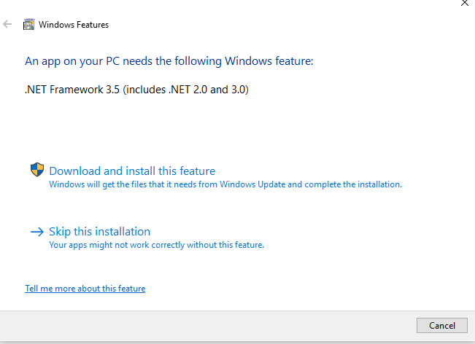

Kindly go through below step.

- Run the setup as an administrator from below path -
\\10.64.255.18\d$\softwares\Microsoft .NET Framework 3.5 Offline Installer
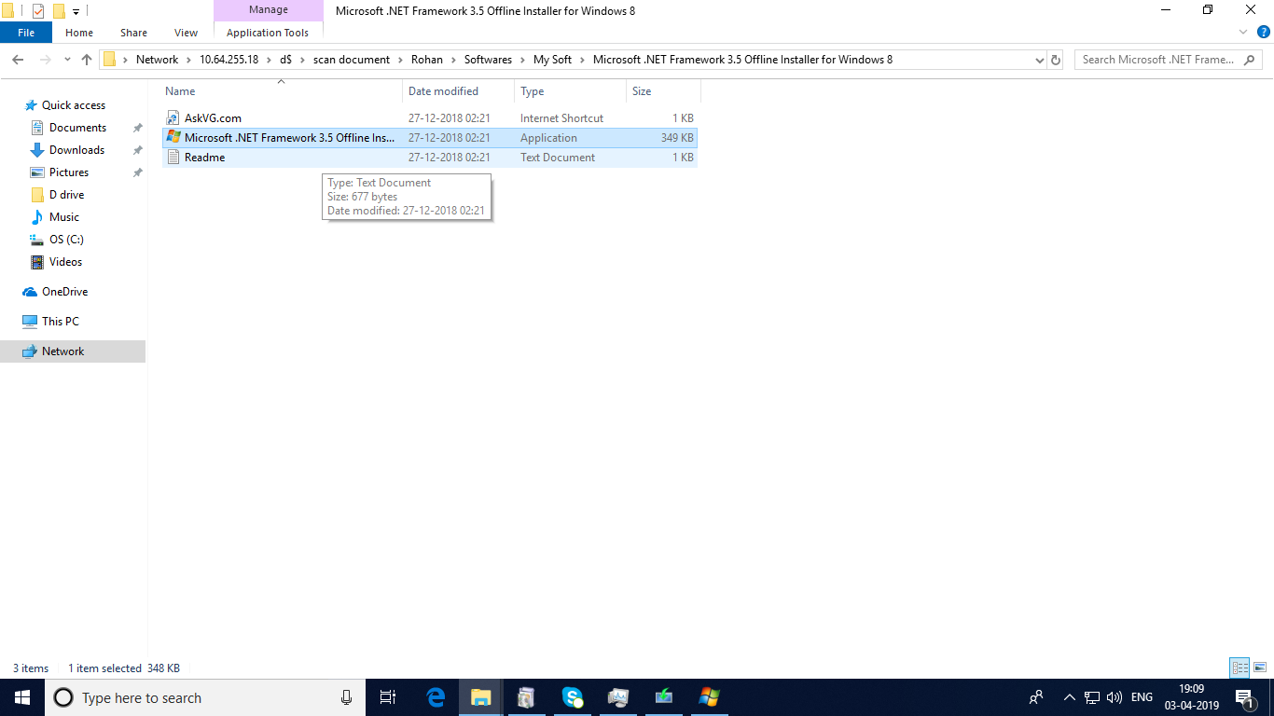

2) copy the sources folder from the path –
\\10.64.255.18\e$\sources & Paste it in the system in which .net 3.5 needs to be activated..

3) Select installation media drive in which Sources folder is placed. [E.g D drive]

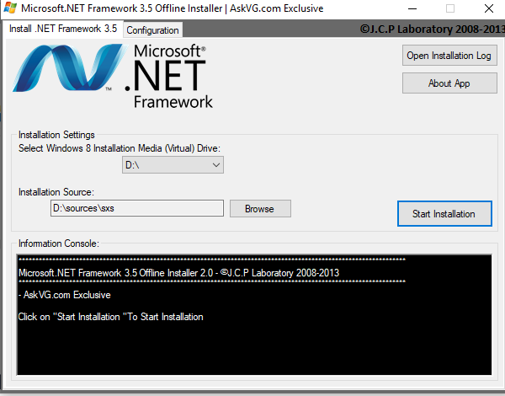
Then click on start installation.

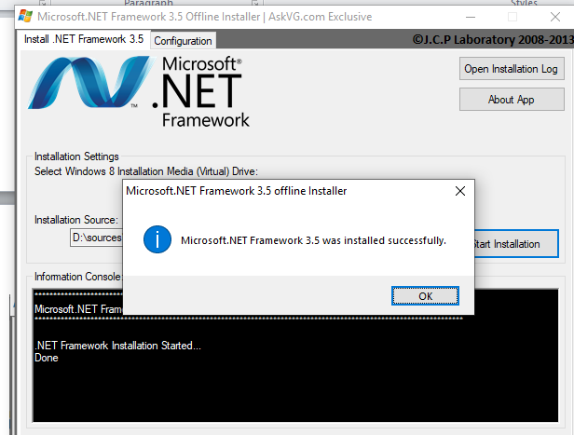

4) After completion of the installation go to –

Run -> appwiz.cpl -> Turn windows feartures on or off

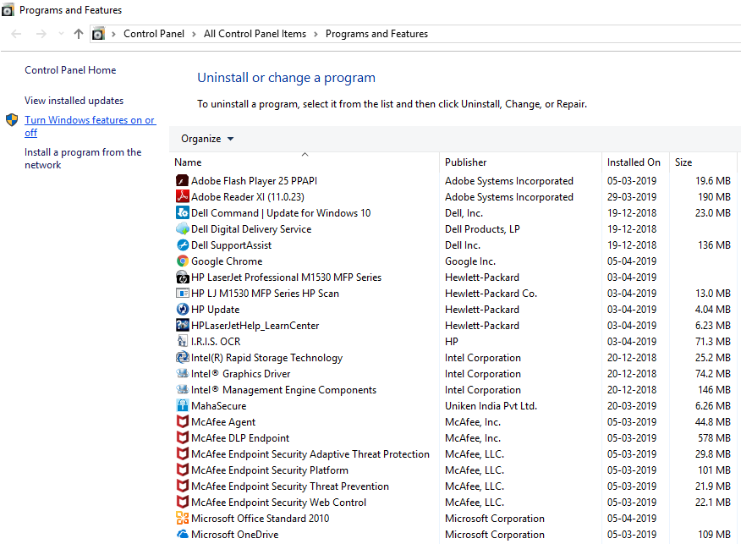

5) Select the Check Boxes in front of .Netframwork 3.5 (includes .Net 2.0 and 3.0)
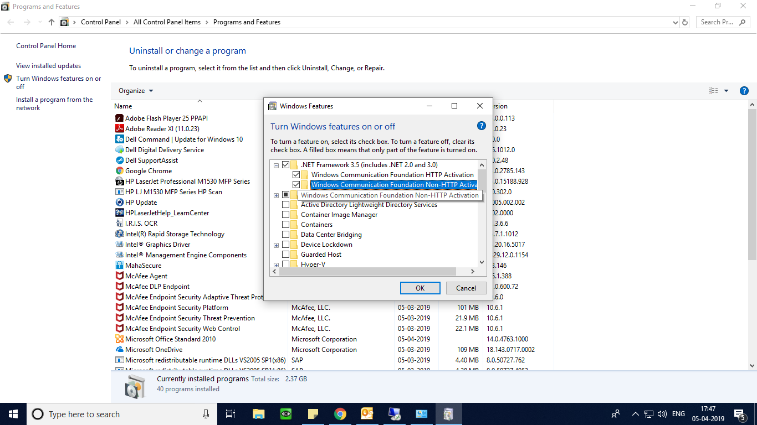

6) After selecting the Check Box’s Press OK.

Done.

